Northeast Connecticut
Regional Family
Resource Guide
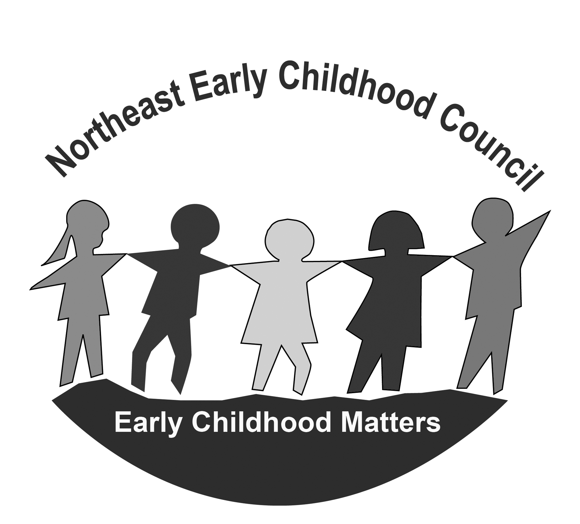

C
E
N
C
Northeast Early Childhood Council
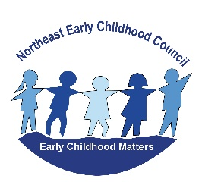

Communities working together to ensure all children, birth through age eight, in Brooklyn, Killingly, Plainfield, Putnam, Sterling & Thompson are Healthy, Safe
and Successful Learners
The Northeast Early Childhood Council (NECC) is a local early childhood council made up of a group of community members from Brooklyn, Killingly, Plainfield, Putnam, Sterling & Thompson. The Council was established in 2001 as the governing council for those towns who receive school readiness grant funding for preschool and has also been part of a long standing regional effort to support the potential for all children and families. We continually build strong relationships with key partners in our communities to assess needs, coordinate efforts and share resources, skills and ideas. We collect data, develop strategies and implement actions in the areas of early care & education, social, emotional & physical health and family support and engagement.

The NECC meet several times per year and is open to all community members who wish to participate on any level.

For more information, contact:
Kristine Cicchetti, Regional Director
860-779-6770,
401-323-4317 (cell)
mrscicch95@sbcglobal.net

Like Us on Facebook @nechildhoodcouncil
Visit our website: www.neccouncil.org

Revised: June 2020

Resource Web Sites

www.cyfernet.org high quality, research based information for parents and professionals.
www.zerotothree.org national non-profit organization dedicated to advancing healthy development of infants and toddlers.
www.aboutourkids.org New York University web site offers scientifically based mental health and parenting information.
www.naeyc.org National Association for the Education of Young Children contains information about child development for families.
www.bornlearning.org Web site for the Born Learning Campaign- an initiative of “Success by 6,” United Way of America.
www.ct.gov/oec/site/default.asp CT Office of Early Childhood, improving outcomes for children, birth- 5
www.parentsasteachers.org parenting/child development resource.
http://eclkc.ohs.acf.hhs.gov/hslc Early Childhood Knowledge and Learning Network web site from Federal Offices of Head Start /up-to-date information and resources for parents and professionals.
www.nimh.nih.gov General information on mental health issues, including informational brochures, can be found at the National Institute of Mental Health.
www.ct.gov/dmhas CT Mental Health and Addiction Services website.
www.pathct.org PATH Parent to Parent/Family Voices of Connecticut is a network of families providing informational and emotional support to others who have a child with developmental or health related needs. PATH/FVCT reaches out to help strengthen families coping with similar situations in Connecticut, and the organizations that serve them to reduce isolation, empower families as advocates for their children and reaffirm their values as parents and caregivers.
www.ct.gov/triplep/site/default.asp A place where you can get help with parenting. Maybe you are seeking parenting advice or just some tips on parenting.

FAMILY ASSISTANCE

Infoline………………………………………………………………………………………………………..... 211 or www.211ct.org
ACCESS Agency…………………………………………………………………………………….. ……… (860) 412-1600
Canterbury Cares Food Pantry……………………………………………………………………... (860) 546-9007
Catholic Charities & Family Services……………………………………………………………… (860) 889-8346
Community Kitchens of Northeast CT…………………………………………………………… (860) 779-2645
CT Care 4 Kids – Child Care Assistance………………………………………………………….. (888) 214-5437
Daily Bread Soup Kitchen – Putnam………………………………………………………………. (860) 928-0169
DKH Nurturing Families Network……………………………………………………….............. (860) 928-6541 ext. 2077
DSS Food Stamp Program…………………………………………………………………….. ………. (800) 842-1508
Friends of Assisi Food Pantry – Killingly...........………………………………………………. (860) 774-2310
Interfaith Human Services of Putnam……………………………………………………………. (860) 928-0169
Killingly Free Community Store……………………………………………………………..………. (860) 779-6773
Project Northeast Food Pantry/Support – Putnam………………………………………… (860) 928-4078
Project Pin Food Pantry – Plainfield……………………………………………………… ………. (860) 527-8106
Salvation Army Thrift Store – Killingly…………………………………………………… ………. (860) 527-8106
Salvation Army Satellite Site – Putnam………………………………………………............. (860) 963-7602
St. Vincent de Paul – Norwich……………………………………………………………………….. (860) 889-7374
Thompson Ecumenical Empowerment Group (TEEG)……………………………………. (860) 963-3458
Women, Infant & Children (W.I.C) Food Assistance:
Program……………………………………………………………………………………. ………. (860) 928-3660
Diaper Bank…………………………………………………..………………………………….. (860) 928-0169

HOSPITAL AND EMERGENCY NUMBERS

Medical Emergency……………………………………………………………………………………….. 911
Poison Control………………………………………………………………………………………………. (800) 222-1222
Day Kimball Hospital:
Main Number…………………………………………………………………………………….. (860) 928-6541
Emergency Department…………………………………………………………………….. (860) 774-3366
William Backus Hospital:
Main Number……………………………………………………………………………………. (860) 889-8331
Emergency Department……………………………………………………………………. (860) 823-6389
Backus 24 Hour Urgent Care Center………………………………………………….. (860) 230-2830
Windham Hospital:
Main Number……………………………………………………………………………………. (860) 456-9116
Emergency Department……………………………………………………………………. (860) 456-6715

DID YOU KNOW….?
- The brain develops 90% of its capacity in the first five years of life.
- What an infant or toddler does during the course of a day influences lifelong learning patterns.
- Oral and dental health from birth impacts overall health and learning.
- The number and variety of spoken words that a child has by age 5 influences his/her ability to be a successful reader.
- Sharing books and reading aloud with your child from birth allows for special quiet time together and supports the joy of reading.
- High quality preschool or childcare is positively related to children’s success in school. Poor quality can have negative effects.

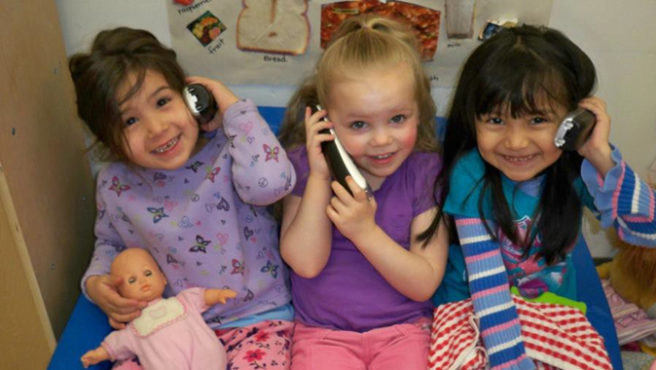

POLICE AND FIRE NUMBERS
Police, Fire, Emergency………………………………………………………………………………….. 911
Local Department Numbers:
Brooklyn Fire Marshall…………………………………………………………………………………. (860) 779-0472
Killingly Fire Marshall……………………………………………………………………………………. (860) 779-5315
Killingly Police Department…………………………………………………………………………… (860) 779-3900
Plainfield Fire Marshall…………………………………………………………………………………. (860) 230-3013
Plainfield Police……………………………………………………………………………………………. (860) 564-0804
Putnam Fire Marshall…………………………………………………………………………………… (860) 963-6800
Putnam Police (city limits only)……………………………………………………………………… (860) 928-6565
State Police Troop D………………………………………………………………………………………. (860) 779-4900
Sterling Fire Departments…………………………………………………………………………….. (860) 564-7435
Thompson Fire Departments (served by 5 departments)……………………………… 911

COMMUNITY PROGRAMS AND RESOURCES
Infoline……………………..…………………………………………………………………………………. or www.211ct.org
Big Brother/Big Sister…………………………………………………………………………………… (860) 525-5437
Boy Scouts of America – CT Rivers Council…………………………………………………… (800) 414-2433
Brooklyn Cooperative Extension Center………………………………………………………. (860) 774-9600
Brooklyn Parks & Recreation Department…………………………………………………… (860) 779-3411
Brooklyn Town Hall…………………………………………………………………………………….. (860) 779-3411
CT Family Support Network – Northeast…………………………………………………….. (860) 546-9289
Girl Scouts of CT –Lebanon Service Center………………………………………………….. (860) 423-5502
Hale YMCA Youth and Family Center – Putnam........…………………………………… (860) 315-9622
Help Me Grow/Child Development Infoline………………………………………………… (800) 505-7000
Killingly Family Resource Center………………………………………………………………….. (860) 779-6770
Killingly Parks & Recreation Department…………………………………………………….. (860) 779-5390
Killingly Town Hall………………………………………………………………………………………. (860) 779-5300
Plainfield Family Resource Center………………………………………………………………. (860) 564-6411
Plainfield Senior Center………..…………………………………………………………………….. (860) 564-1455
Plainfield Town Hall……………………………………………………………………………………. (860) 230-3000
Plainfield Senior Center……………………………………………………………………………… (860) 564-1819
Putnam Family Resource Center………………………………………………………………… (860) 963-6940
Putnam Parks & Recreation ………………………………………………………………………. (860) 963-6811
Putnam Town Clerk……………………………………………………………………………......... (860) 963-6800
Quinebaug Regional Senior Center……………………………………………………………. (860) 774-1243
Thompson Ecumencial Empowerment Group (TEEG)………………………………… (860) 923-3458
Thompson Recreation Department……………………………………………………………. (860) 923-9440
Thompson Town Clerk ………………………………………………………………………………. (860) 923-9900
Sterling Town Hall……………………………………………………………………………………… (860) 564-2904
Sterling Parks & Recreation……………………………………………………………………….. (860) 564-2136

TRANSIT

Infoline……………………..………………………………………………………………………………… 211 or www.211ct.org
Medical Cab Services………………………………………………………………………………….. (855) 478-7350
Northeast Connecticut Transit District – Dayville………………………………………… (860) 774-3899
Plainfield Recreation Transit Department……………………………………………………. (860) 564-1819

EMPLOYMENT

Infoline……………………..………………………………………………………………………………… 211 or www.211ct.org
ACCESS Agency Job Source Community Services………………………………………... (860) 774-0418
Employment Services – Danielson………………..…………………………………………….. (860) 566-5790
Department of Labor…………………………………………………………………………………… (860) 263-6000
Unemployment Compensation Claims - Danielson………………………………………. (860) 423-2521

JOB TRAINING

Infoline……………………..………………………………………………………………………………… 211 or www.211ct.org
ARC of Quinebaug Valley…………………………………………………………………………….. (860) 774-2827
EASTCONN Learning Center……………….……………………………………………………….. (860) 779-3770
United Services…………………………………………………………………………………………… (860) 774-2020

HOUSING ASSISTANCE

Infoline……………………..………………………………………………………………………………… 211 or www.211ct.org
Housing Authorities Section 8 (HUD)
Brooklyn Housing Authority………………………………………………………………………… (860)779-3339
Killingly Housing Authority………………………………………………………………………….. (860) 774-6067
Killingly Section 8………………………………………………………………………………………… (860) 774-3905
Plainfield Housing Authority……………………………………………………………………….. (860) 230-3022
Plainfield Section 8………………………………………………………………………………………. (860) 230-3022
Putnam Housing Authority…………………………………………………………………………… (860) 963-6829
Thompson Housing Authority………………………………………………………………………. (860) 923-9997
ACCESS Agency Emergency Shelter………………………………………………………………. (860) 774-4977
CT Housing Finance Authority………………………………………………………………………. (860) 721-9501
Connecticut Legal Services…………………………………………………………………………… (860) 344-0447
Covenant Shelter of New London…………………………………………………………………. (860) 443-0537
Habitat for Humanity Northeast CT………………………………………………………………. (860) 442-7890
Holy Family Home & Shelter for Women & Children-Willimantic…………………. (860) 423-7719
Plainfield Housing – Elderly/Disabled…………………………………………………………… (860) 779-3339
Thompson Ecumencial Empowerment Group (TEEG)………………………………… (860) 923-3458

ENERGY ASSISTANCE

Infoline……………………..………………………………………………………………………………… 211 or www.211ct.org
ACCESS Fuel Assistance and Winterization…………………………………………….……. (860) 774-0418
EverSource Assistance………………………………..……………………………………………….. (800) 592-2000
Operation Fuel United Methodist Fuel Bank……………………………………………….. (860) 774-0106
Thompson Ecumencial Empowerment Group (TEEG)………………………………… (860) 923-3458

FAMILY HEALTH NUMBERS

Across the Smiles Generations Dental Van………………………………………………….. (860) 963-0010
American Red Cross…………………………………………………………………………………….. (800) 448-3543
Backus Hospital Plainfield Emergency Care Center………………………………………. (860) 230-2830
Center for Healthy Aging……………………………………………………………………………… (800) 273-0078
Community Providers Association of Mental Health Clinics for Children……… (860) 257-7909
CT Department of Social Services – Willimantic Office…………………………………. (866) 327-7700
Day Kimball Medical Group – Plainfield……………………………………………………….. (860) 564-6200
Day Kimball Medical Group – Putnam…………………………………………………………. (860) 963-6390
Day Kimball Medical Group – Thompson…………………………………………………….. (860) 923-1141
DCF Child Abuse Hotline……………………………………………………………………………… (800) 842-2288
FAVOR – Family Advocacy for Children’s Mental Health………………………………. (860) 563-3232
Generations Family Health Center – Danielson……………………………………………. (860) 774-7501
Generations Family Health Center – Putnam………………………………………………. (860) 963-7917
Generations School Based Health Center……………………………………………………. (860) 928-4698
Husky Health Care Plan Information ………………………………………………………….. (877) 284-8759
Maternal/Child Health Infoline……………………………………………………………………. (800) 505-2000
Northeast District Department of Health……………………………………………………. (860) 774-7350
Plainfield Walk-in Center…………………………………………………………………………….. (860) 564-4054
United Community and Family Services – Child First Program…………………….. (860) 822-4905
United Services Child Guidance Clinic…………………………………………………………. (860) 774-2020
Or…………………………………………………………………………………………………………. (860) 228-4480

JOB TRAINING

Infoline………………………………………………………………………………………………………… 211 or www.211ct.org
ARC of Quinebaug Valley……………………………………………………………………………… (860) 774-2827
Danielson America Job Center………..…………………………………………………………… (860) 774-4077
EASTCONN Northeast Adult Education………………………………………………………… (860) 779-3770
United Services……………………………………………………………………………………………. (860) 774-2020

ADULT EDUCATION

Infoline………………………………………………………………………………………………………… 211 or www.211ct.org
EASTCONN Community Learning Center-Windham…………………………………….. (860) 423-2591
EASTCONN Northeast Learning Center ………………………………………………………. (860) 779-3770
Eastern Connecticut State University………………………………………………………….. (860) 465-5000
Education & Employment Information Center…………………………………………….. (800) 842-0229
Quinebaug Valley Community College…………………………………………………………. (860) 932-4000
Three Rivers Community College…………………………………………………………………. (860) 886-0177
Parents are their children’s first and most important teacher
BRING OUT THE BEST IN YOUR CHILDREN BY NOTICING POSITIVE BEHAVIOR:
- Comment on your child’s positive behavior.
- Notice effort and improvement.
- Appreciate your child’s contributions even if small.
- Express confidence in your child.
- Express delight in your child often.
WHY DO PEOPLE NEED HELP WITH PARENTING? DOESN’T IT COME NATURALLY?
HAVING A CHILD CHANGES OUR LIVES DRAMATICALLY. Most parents want to do a good job yet most of us are not always sure how. We don’t all have the support we need. Sometimes as parents we feel isolated and frustrated about our abilities. Sometimes we want to talk about our daily lives with someone who understands.
PARENTING IS THE MOST IMPORTANT, CHALLENGING, AND REWARDING JOB WE WILL EVER HAVE. All parents can learn positive skills and better ways to be with children.
MOST PARENTS FIND IT VERY HELPFUL TO JOIN A GROUP OR CLASS OR MEET WITH HOME VISITORS. Most parents who receive help say that it improves life with their children. Most parents who get support would recommend that others do the same. Contact a Family Resource Center to find out what it offers to support you and your child.
PARENTING CLASSES
Day Kimball Hospital Nurturing Families Network………………………………………. (860) 928-6541 x 2077
Killingly Family Resource Center…………………………………………………………………. (860) 779-6770
Plainfield Family Resource Center………………………………………………………………. (860) 564-6411
Putnam Family Resource Center…………………………………………………………………. (860) 963-6940
Thompson Ecumencial Empowerment Group (TEEG)………………………………….. (860) 923-3458
UCONN Cooperative Extension Center……………………………………………………….. (860) 486-9228
United Services Parent Education Program………………………………………………… (860) 564-6100

INFORMATION & REFERRAL
Infoline………………………………………………………………………………………………………… 211 or www.211ct.org
Children’s Law Center…………………………………………………………………………………. (860) 232-9993
Child Support Enforcement Call Center………………………………………………………. (800) 228-5437
CT DCF Willimantic Regional Office…………………………………………………………….. (860) 450-2000
CT DCF Careline-Report Child Abuse & Neglect…………………………………………… (800) 842-2288
CT DCF Ombudsman-Community Relations………………………………………………… (866) 637-4737
CT Legal Services – Willimantic……………………………………………………………………. (860) 456-1761
CT Women’s Education and Legal Fund……………………………………………………….. (800) 479-2949
CT Family Support Network…………………………………………………………………………. (860) 546-9289
Day Kimball Hospital Nurturing Families……………………………………………………… (860) 928-6541 Ext. 2077
Killingly Family Resource Center…………………………………………………………………… (860) 779-6770
National Runaway Switchboard…………………………………………………………………… (800) 621-4000
Northeast Communities Against Substance Abuse………………………………………. (860) 779-9253
Plainfield Family Resource Center…….…………………………………………………………. (860) 564-6411
Putnam Family Resource Center………………………………………………………………….. (860) 963-6940
Thompson Ecumencial Empowerment Group (TEEG)………………………………….. (860) 923-3458
United Services Domestic Violence Program Hotline…………………………………… (860) 774-8648
Women’s Center of NE CT Sexual Assault Crisis Services……………………………… (860) 456-2789

School Success Goes Hand In Hand With Good Attendance!
Early Years Matter! Build good attendance habits early!
Did You Know?
Missing one or two days every few weeks can:
- Make a child fall behind.
- Develop poor attendance habits that are hard to break.
- Make it harder to develop early reading skills.
- Affect the whole classroom as learning has to slow down to help children catch up.

What Can You Do?
- Set regular bed times and morning routines.
- Don’t let your child stay home unless he or she is truly sick.
- Develop back-up plans for getting to school if something comes up.
- Avoid medical appointments and extended trips when school is in session.
- Talk to your child’s teacher or social worker if your child seems anxious about going to school.
- Teach your child that attending school is non-negotiable - children CAN’T learn if they aren’t in school.
AREA SCHOOLS

Brooklyn (www.brooklynschools.org)
Brooklyn Elementary School……………………………………………………………… (860) 774-7577
Brooklyn Middle School……………………………………………………………………. (860) 774-9153
Superintendent’s Office……………………………………………………………………. (860) 774-9153

Killingly (www.killinglyschools.org)
Family Resource Center/Goodyear Early Childhood Center………....…… (860) 779-6770
Killingly Central School………………………………………………....………………….. (860) 779-6750
Killingly Memorial School………………………………………………………………….. (860) 779-6680
Killingly Intermediate School ……..…………………………………………………….. (860) 779-6700
Killingly High School ……….………………………………………………………………… (860) 779-6620
Pupil Services……………………………………………………………………………………. (860) 779-6740
Superintendent’s Office…………………………………………………………………….. (860) 779-6600

Plainfield (www.plainfieldschools.org)
Family Resource Center…………………………………………………………………….. (860) 564-6411
School Readiness Program………………………………………………………………… (860) 230-0827
Early Childhood Center……………………………………………………………………… (860) 564-6400
Shepard Hill Elementary School…………………………………………………………. (860) 564-6432
Moosup Elementary School………………………………………………………………. (860) 564-6430
Plainfield Memorial School……………………………………………………………….. (860) 564-6440
Plainfield Central School……………………………………………………………………. (860) 564-6437
Plainfield High School………………………………………………………………………… (860) 564-6422
Pupil Services / Special Education……………………………………………………… (860) 564-6401
Superintendent’s Office…………………………………………………………………….. (860) 564-6403

Putnam (www.putnam.k12.ct.us)
Family Resource Center…………………………………………………………………….. (860) 963-6940
School Readiness Program………………………………………………………………… (860) 963-6940
Putnam Elementary School………………………………………………………………. (860) 963-6925
Putnam Middle School…………………………………………………………..…………. (860) 963-6920
Putnam High School……………………………………….………………….……………… (860) 963-6905
Student Services ……………………….……………………………………………………… (860) 963-6926
Superintendent’s Office…………………………………………………………………….. (860) 963-6900

Sterling (www.sterlingschool.org)
Sterling Community School………………………………………………………………… (860) 564-2728
Superintendent’s Office…………………………………………………………………….. (860) 564-4219

Thompson (www.district.thompsonk12.org)
Mary R. Fisher Elementary School………………………………………………………. (860) 923-9142
Thompson Middle School…………………………………………………………………… (860) 923-9380
Tourtellote Memorial High School…………………………………………………….. (860) 923-9303
Superintendent’s Office…………………………………………………………………….. (860) 923-9581

What to look for and ask when observing an early childhood program

Choose an early childhood program where the teachers consistently:

Use a gentle tone of voice.
- Talk in a warm and friendly way.
- Laugh with the children.
- Show affection to the children.
- Respond to children’s needs.
- Bend down to speak to children at eye level.
- Provide individual attention to children.
- Help children learn to get along with others.
- Talk with parents about their children.
- Refrain from using a harsh tone of voice or using put-downs.
- Understand child growth and development.
- Provide exciting and engaging learning activities.
- In preschool programs, use the CT Preschool Curriculum Framework to plan learning experiences.

To learn other signs of quality early childcare programs, visit
www.learningpolicyinstitute.org
Enroll children in a preschool, Head Start, or similar community program, which will provide an opportunity to be with other kids and make new friends. Children can also learn academic basics as well as how to make decisions and cope with problems

EARLY CARE & EDUCATION OPTIONS
Infoline………………………………………………………………………………………………. 211 or 211childcare.org
CT Care 4 Kids……………………………………………………………………………………. 888-214-5437 ctcare4kids.com
Connecticut Birth to Three………………………………………………………………… 866-888-4188
211 Child Care Referral Line………………………………………………………………. 800-505-1000
Regional EASTCONN Head Start Information…………………………………….. 860-455-0707 www.eastconn.org/head-start

Brooklyn
Brooklyn Public Schools Preschool Program……………………………………… (860) 774-7577
Village Green Pre-School………………………………………………………………….. (860) 774-3439
Brooklyn Recreation Before & After School Program……………………….. (860) 779-3911
Carelot Children’s Center-Brooklyn………………………………………………….. (860) 779-0400

Killingly
Carelot Children’s Center – Killingly…………………………………………………… (860) 779-0611
Castle Kids…………………………………………………………………………………………. (860) 779-9002
EASTCONN Killingly Head Start & Early Head Start…………………………….. (860) 779-0410
EASTCONN Head Start at Killingly High School…………………………………… (860) 779-0410
Killingly Family Resource Center………………………………………………………… (860) 779-6770
St. James Preschool……………………………………………………………………………. (860) 774-3281
The Owl’s Nest Day School, Inc………………………………………………………….. (860) 774-4375

Plainfield
EASTCONN Head Start……………………………………………………………………….. (860) 564-7199
Kid and Kaboodle……………………………………………………………………………….. (860) 564-5581
Plainfield Family Resource Center………………………………………………………. (860) 564-6411
Plainfield Readiness Program……………………………………………………………… (860) 230-0827

Putnam
Country Kids Day Care………………………………………………………………………… (860) 928-2588
EASTCONN Putnam Head Start…………………………………………………………… (860) 928-0004
Imagination Station……………………………………………………………………………. (860) 963-7655
Putnam Preschool & Childcare, LLC...…………………………………………………. (860) 963-2587
Putnam Family Resource Center…………………………………………………………. (860) 963-6940

Sterling
Jordan Pre-School & Daycare……………………………………………………………… (860) 774-1881
Sterling Public Schools Preschool……………………………………………………….. (860) 564-2728

Thompson
Building Blocks Child Care & Preschool………………………………………………. (860) 923-2162
Linda’s House: Pediatric Day Care & Preschool…………………………………. (860) 315-5600
Little Foot Day Care and Preschool Child Care Center……………………….. (860) 923-2261
St. Joseph’s Child Care Center……………………………………………………………. (860) 923-2090
Thompson Public Schools Pre-School Program………………………………….. (860) 923-9142
The Country Garden Child Care Center……………………………………………… (860) 923-0440

5 STEPS TO FINDING A GOOD CHILDCARE OR PRESCHOOL
- START EARLY: Finding the right childcare option can take some time.

- MAKE A CALL: Call your Family Resource Center or call 211 Infoline and ask:
- What are the licensing requirements in my area? Remember that licensed programs meet basic regulations required by law.
- What types of programs are available?
- How can I get information about complaints and licensing violations?
- Is there any childcare financial assistance?

3. VISIT, ASK QUESTIONS & TAKE THE TIME TO OBSERVE.
- How many children are there for each adult? One adult to 3 or 4 infants and toddlers; one adult to 7 or 8 preschool aged is best.
- How many children are in a group? In a center, group size is 8 or less for infants and toddlers, or 17 in a preschool program.
- Ask about caregivers’ training and education.
- Ask how long the caregivers have been at that center or providing care in their homes.
- Find out if the provider is accredited by a national organization (such as NAEYC). Accredited programs meet higher standards of quality.

- MAKE A CHOICE. Think about what you saw at each visit and make the best choice for your child and your family.

- STAY INVOLVED. Meet with caregivers regularly, visit your child at childcare and join in special events.

www.ChildCareAware.org
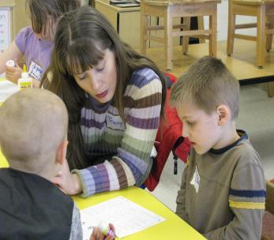

MENTAL HEALTH
Every person, child or adult, needs to be emotionally and mentally well in order to live a happy life. Living with mental and emotional problems, including addictions, takes a hard toll on entire families. When families get help for behavioral and mental health issues, the lives of everyone in the family can be transformed. Attitudes change from despair to hope.
The brief directory below has been put together with the goal that families can get help by just making a call or two. Many of the agencies listed provide emergency evening and weekend numbers. If you think that you or someone you love might need help, call these experts. Their agencies exist to serve our needs.
Please refer to the Transit section for help with transportation. Husky users may use the phone number on the back of their card.

MENTAL HEALTH & BEHAVIORAL / SUBSTANCE ABUSE
Basic Behavioral Screenings for Ages 0-5 using the Ages & Stages Questionnaire
Killingly Family Resource Center………………………………………………………... (860) 779-6770
Plainfield Family Resource Center……………………………………………………… (860) 564-6411
Putnam Family Resource Center………………………………………………….…….. (860) 963-6940

Catholic Charities http://www.ccfsn.org
Norwich Office………………………………………………………………………………….. (860) 889-8346
Willimantic Office……………………………………………………………………………… (860) 423-7065
Behavioral Health Assessments (assessments, counseling, medication management, crisis intervention, adolescent substance abuse, emergency services, parenting education)
COST: Accepts most insurances, sliding scale

Community Health Resources (CHR)………………………………………………….. (877) 884-3571
http://www.chrhealth.org/child-family
Assessment and care coordination for children 0-17 with emotional/behavioral difficulties, care coordinators develop family-centered treatment plans and provide linkage to and coordination of services.
COST: No charge for care coordination

Day Kimball Hospital Behavioral Health Services….…………………………… (860) 963-6385
https://www.daykimball.org/patient-services/behavioral-health
Behavioral health services help people of all ages to address a wide range of behavioral and psychiatric conditions through a caring and comprehensive approach that’s integrated with the rest of your medical care.
COST: Accepts Insurances including Husky, Medicare, Medicaid, self-pay

Dept. of Children & Families Voluntary Services Program………………… (800) 842-2288
http://www.portal.ct.gov/DCF/Behavioral-Health-Partnership/Voluntary-Services-Program
The Voluntary Services program is for children and youth with serious emotional disturbances, mental illnesses and/or substance dependency. This program is only for families who are not abusive or neglectful. Parents and families are critical participants in this program and are required to participate in the planning and delivery of services for their child or youth. The Voluntary Services Program promotes positive development and reduces reliance on restrictive forms of treatment and out-of-home placement.
COST: FREE

Dept. of Children & Families Voluntary Services Program…………………. (860) 704-6378
http://www.eccpct.com
The Early Childhood Consultation Partnership (ECCP®) is a strengths-based, mental health consultation program, developed to meet the social/emotional needs of children birth to five. ECCP® is designed to build the capacity of caregivers by offering support, education, and consultation, which promotes the most enduring and optimal outcomes for young children.
COST: FREE

Emergency Mobile Psychiatric Services (EMPS)…………….………………….. 211
http://www.portal.ct.gov/DCF/Behavioral-Health-Partnership/Emergency-Mobile-Psychiatric-Services
This service provides emergency services including mobile response; psychiatric assessment; medication consultation, assessment, and short-term medication management; behavioral management services; substance abuse screening and referral to traditional and non-traditional services for any family with a child in crisis. The centralized number is accessible 24 hours per day, 7 days per week, 365 days per year.
COST: FREE

Generations Family Health Center – Behavioral Health
http://www.genhealth.org/programs-a-services/behavioral
Putnam………………………………………………………………………………………………. (860) 963-7917
Putnam Middle School……………………………………………………………………….. (860) 928-4698
Willimantic…………………………………………………………………………………………. (860) 450-0585
Generations Family Health Center provides a full range of behavioral health services for all ages, including: Diagnostic and Assessment Services, Individual Counseling, Group Therapy, Family and Marital Counseling, Psychiatric Evaluations, Medication Therapy
COST: Accepts Medicaid, HUSKY, private insurance or those who are uninsured

National Alliance for Mental Illness (NAMI)……………………………………… (860) 882-0236
https://www.namict.org
Outreach programs, mental health support and education.
COST: FREE

Perception Programs…………………………………………..……………………………… (860) 420-2450
https://www.perceptionprograms.org
Perception Programs provides hope and recovery to people affected by substance use and mental health problems. If you’re feeling depressed, confused, or angry or if you have a friend or family member facing difficulties, we can help. Our highly trained staff can provide you with quality substance use and mental health treatment services.
COST: Accepts insurance
United Community & Family Services (UCFS)…. ………………………………… (860) 892-7042
https://www.ucfs.org
Comprehensive medical, dental, women’s health and behavioral health services for adults, children and families. Outpatient and community-based behavioral health evaluation and treatment services including individual and family therapy.
COST: Accepts insurance, sliding scale for uninsured - visit website for detailed information

United Services………………………………………………….……………………………… (860) 774-2020
http://unitedservicesct.org
Comprehensive behavioral health, mental and substance abuse evaluation and treatment for adults, children and families. Child guidance clinic, family services, emergency and psychiatric consultation under medical oversight. Spanish speaking services available.
COST: Accepts insurance, sliding scale for uninsured - visit website for detailed information

ADDICTION RECOVERY / SUBSTANCE USE PROGRAM & DETOX TREATMENT
Alcohol & Drug Recovery Centers (ADRC) – Hartford…………………………. (860) 714-3700
Alliance Treatment Center…………………………………………………………………. (800) 229-4840
Blue Hills Hospital – Hartford…………………………………………………………….. (860) 293-6400
Community Health Resources……………………………………………………………. (877) 884-3571
Natchaug Hospital……………………………………………………………………………… (860) 456-1311
Pathways – Putnam…………………………………………………………………………… (860) 963-4971
Southeast Council on Alcohol & Drug Dependence (SCADD)……………… (860) 447-0381

SUICIDE
National Suicide Prevention Line……………………………………………………….. (800) 273-8255
Southeastern Mental Health Authority……………………………………………… (860) 886-9302
(866) 859-4500
Suicide Infoline……………………………………………………………………………………………………….211

LEGAL ASSISTANCE
Protection & Advocacy for Individuals with Mental Illness…………………… (877) 726-4727

GENERAL / ADDITIONAL INFORMATION RESOUCES
General information on mental health issues, including informational brochures, can be found at the National Institute of Mental Health website: www.nimh.nih.gov

Information on addition services is available at the CT Mental Health and Addiction Services website:
www.ct.gov/dmhas

IS YOUR FAMILY LIVING IN ANY OF THESE SITUATIONS:
In a shelter?
In a motel or campground due to the lack of an alternative adequate accommodation?
In a car, park, abandoned building, or bus or train station?

Doubled up with other people due to loss of housing or economic hardship?
Then your school-age children may qualify for certain rights and protections under the federal McKinney-Vento Act.
Your eligible children have the right to:
- Receive a free, appropriate public education.
- Enroll in school immediately, even if lacking documents normally required for enrollment.
- Enroll in school and attend classes while the school gathers needed documents.
- Enroll in the local school; or continue attending their school of origin (the school they attended when permanently housed or the school in which they were last enrolled), if that is your preference.
- If the school district believes that the school you select is not in the best interest of your children, then the district must provide you with a written explanation of its position and inform you of your right to appeal its decision.
- Receive transportation to and from the school of origin, if you request this.
- Receive educational services comparable to those provided to other students, according to your children’s needs.
If you believe your children may be eligible, contact the local liaison to find out what services and supports may be available. There also may be supports available for your preschool-age children.

To find your Town’s liaison, visit: https://portal.ct.gov/SDE/Homeless/Homeless-Education/How-To

State Coordinator
Louis Tallarita, 860-807-2058
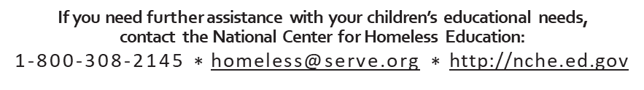

Youth Service Bureau’s
What is a Youth Service Bureau (YSB)?
A YSB is an agency that is responsible for providing services and programs for all youth to develop positively and to function as responsible members of their communities. Additionally, YSBs assess needs of youth, identify gaps in service and coordinate services to fill those gaps. The services YSBs provide may involve programs related to youth development, juvenile justice, truancy prevention, and connection to community resources. United Services, Inc. Youth Service Bureau serves Brooklyn, Canterbury, Eastford, Killingly, Plainfield and Sterling. TEEG’s Youth Service Bureau serves Thompson, Woodstock, Pomfret and Putnam.

A YSB may recommend or provide for any school-aged child:
- Academic supports which could include credit recovery and/or college prep programs
- Referral or access to individual or family mental health services and/or medical care
- Referral to other community-based intervention programs (including in-home services) targeting truancy and other behavioral concerns
- Educational advocacy
- Mediation
- Mentoring
- Parenting classes
- Positive social activities such as art, enrichment, and sports
- Referral for clean clothes, healthy food, stable housing, and/or transportation needs

What will happen when a referral is made to a YSB*?
- Once the YSB has received a complete and signed referral, they will reach out to the family via phone or send a letter to the family’s home.
- YSB staff will explain the process to the family and ensure consent to move forward.
- If the family agrees to participate, the YSB will arrange a time to meet with the student and the family and gather information (including demographics, family & school information and needs and strengths of the student & family).
- The YSB will work with the school to address the individual needs of the student, such as assisting families with school meetings to support the student.
- The YSB will identify available and appropriate community supports for the student and review them with the student and their family.
- Based on family input, YSB staff may provide programming within the YSB and/or make appropriate community referrals.
*This process may be different based on the needs of the family and/or the resources available in your community.

YOUTH SERVICE BUREAU’S – CONTINUED
Tips to maximize school success:

Partner with the school: Develop and strengthen relationships with your child’s teachers and administration.

Be involved: Know what’s going on in your child’s school and classroom. Monitor your child’s school progress - read school newsletters, contact teachers when you have questions, attend parent/teacher conferences, monitor progress through online grading systems, etc.

Pass on high educational aspirations: Encourage positive discussions around school. Talk to your child about the importance of an education and the benefits of school attendance from an early age.

Regularly monitor your child’s electronic devices and social media: Talk with your child about what’s appropriate and boundaries on social media. Open a line of communication without judgement or consequences. If your child is under 18, it’s your responsibility to know phone passwords, spot check social media / texts and be aware of the “apps” they are using.

Prioritize schoolwork: Stress that school and homework come before friends, sports and social media. Engage with your child around homework and follow through with consequences if they don’t meet expectations.

Support your child’s school activity participation: Encourage your child to be involved in extracurricular actives and programs. Kids who feel connected to their school are more likely to have better grades and school attendance.

Get help so your child succeeds: If your child is struggling, don’t be afraid to ask for help – it takes a village! Contact your child’s school to discuss supports.
Youth Service Bureaus
United Services, Inc.
Brooklyn, Canterbury, Eastford, Killingly, Plainfield and Sterling
www.unitedservicesct.org * 860-564-6100

TEEG
Thompson, Woodstock, Pomfret and Putnam
www.teegonline.org * 860-923-3458
Parent referrals are accepted, just contact your local YSB directly

UNITED STATES CONGRESS

Find Your Representative: Not sure of your congressional district or who your member is? This service will assist you by matching your ZIP code to your congressional district, with links to your member's website and contact page.
https://www.house.gov/representatives/find-your-representative

CT GENERAL ASSEMBLY
Find Your Representative, Senator and Congressperson by Town
https://cga.ct.gov/asp/menu/cgafindleg.asp

