***Killingly Intermediate School***

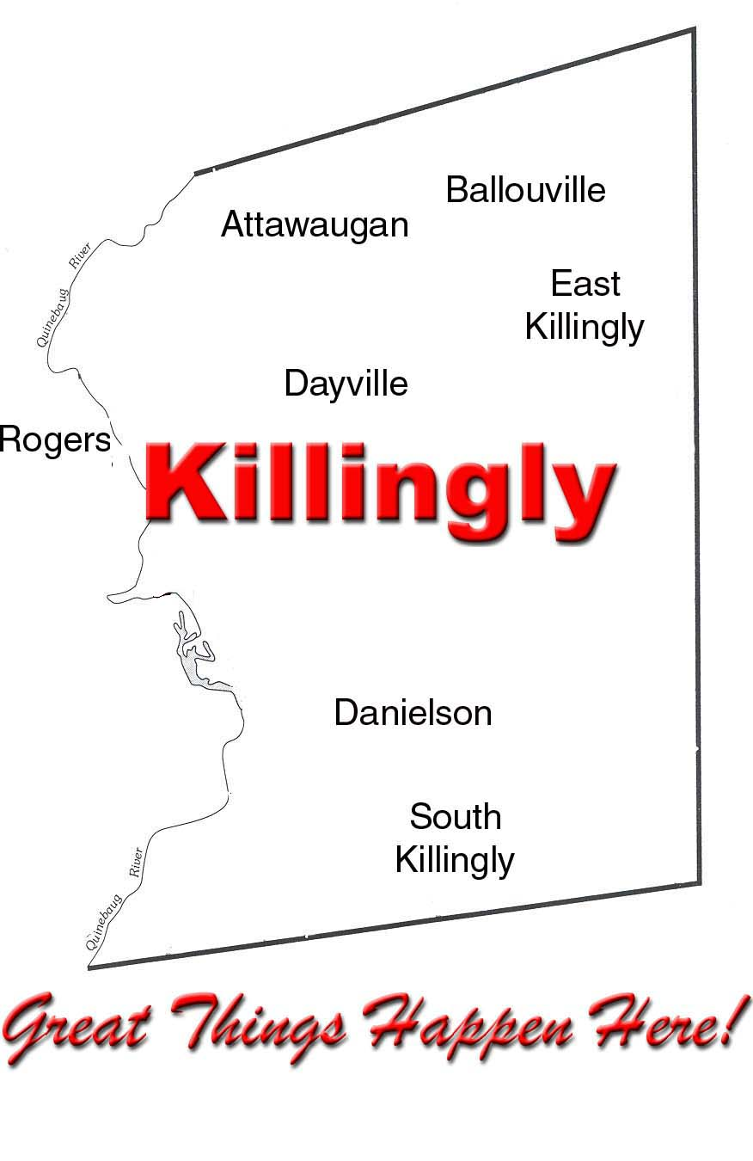

***Tracey DeDonato Kenneth Daniewicz***

***Principal Meredith Tukey***

***Assistant Principals***



April 25, 2022

Dear KIS Families:

The end of the school year is fast approaching and with that comes the time to celebrate a special milestone in the lives of our eighth-grade students! We are excited to be moving the Eighth Grade Recognition Ceremony back to the Killingly Intermediate School Auditorium on Monday, June 13. The Auditorium will be open for seating 30 minutes prior to each event. Each Team will have its ceremony at the following times:

* Red Team: 10:00 AM
* White Team: 12:30 PM

Tickets for the Recognition Ceremony will be distributed to students on Wednesday, June 8. Each student will receive four tickets. Families will be allotted one additional ticket on a first come, first served basis. Please contact Sheri Esch at (860) 779-6705 to request an additional ticket.

The Eighth Grade Dance will be held from 6 PM to 8:30 PM the same evening – June 13, in the Killingly Intermediate School Gymnasium and Cafeteria. Pizza, snacks, and beverages will be served at the dance. For security purposes, doors will be locked at 6:15 PM. Please arrive by 8:15 PM to pick up your child. There is no cost for this dance.

Students must wear appropriate dress to participate in the Recognition Ceremony and Dance. The following dress code is encouraged: Suggested female attire includes a dress, skirt with blouse, or pants with blouse, and dress shoes. Suggested male attire includes a collared shirt, tie, dress pants, and dress shoes. All attire must adhere to school dress code policies (i.e., no sunglasses, hats, visors or bandanas, clothing must completely cover the upper thigh, must not reveal the chest, abdomen or undergarments, and no plunging necklines).

We are all immensely proud of our eighth-grade students and look forward to celebrating their achievements with you.

In Partnership,

Tracey DeDonato

Principal

1599 Upper Maple Street • Killingly, CT 06241 • (860) 779-6700 • Fax: (860) 779-9639