SUPPLY LISTS FOR 2021-2022

Students entering the 6th Grade Students entering the 7th & 8th Grade

- Single 1 1/2” Three ring binder and dividers
- 1 pack colored pencils
- 1 folder with pockets
- 3 highlighters (different colors)
- 1 box of pencils
- Pencil sharpener
- Fine tip dry erase markers
- One 3’ zipper binder or 3 ring binders; tabs for 4-5 subjects
- College Ruled Filler Paper 8 ½ x 11
- 5 Pocket Folders
- Pencil Case (only if it is not included with the binder)
- Pencils
- Erasers
- Pens

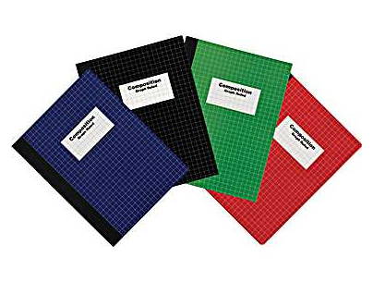

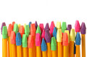

ALL CLASSES
- ear buds/headphones
- pencils (at least 4 boxes)
- pencil top erasers
- 2 pocket folder
- a locker shelf would be helpful
**large, trapper-keeper-like, zippered binders are discouraged
ELA
- 1.5inch binder
- dividers
- 3X3 sticky notes
- 2 composition notebooks (not spiral bound)
- loose leaf paper (reinforced holes if possible)
MATH
- 1.5inch binder
- dividers
- loose leaf paper (reinforced holes if possible)
SCIENCE
- 2 composition notebooks (not spiral bound)

*RECOMMENDED SUPPLY LIST*

